[JavaScript Web Workers Explained](https://www.youtube.com/watch?v=Gcp7triXFjg)

Web worker is simply just a JavaScript process that runs in the background.

JavaScript, by default is a single threaded language, the main thread is responsible for all the processing that happens, which executes the code linewise.

A web worker is another JavaScript thread, which allows multiple JS threads to run in parallel with each other. Instead of main thread doing all the heavy lifting work, the web-workers can be created to perform any computationally expensive work, so that the main thread doesn't get blocked & can perform other important stuff.

|  |  |
| --- | --- |
| **Main Thread** | **Web worker** |
| * 1. Only the main thread can manipulate & access the DOM. | * 1. No DOM Manipulation |
|  |  |

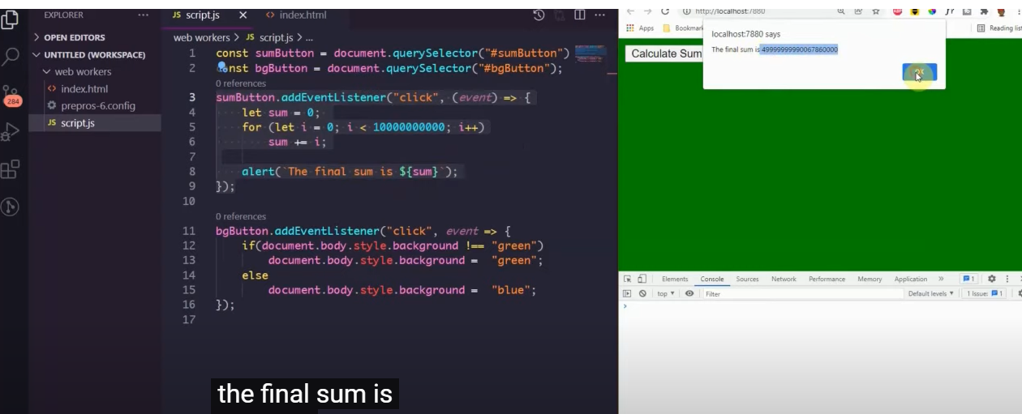

Here, we can't execute back ground change listener after clicking on perform sum action.

Reason - The sum () takes longer to execute & hence the more wait!! Since, all of this is now running on the main thread, hence, the other executions are blocked.

So, we can create a web-worker for the heavy task - eg - perform sum.

Steps -

1. Create instance of the worker.

const worker = new Worker('worker.js');

1. Create a new worker.js script.
2. How to send data from main script (script.js) to worker.js?

=> 'Post Message' api does that for us.

=> It raises an event from one script to another script to catch or listen to.

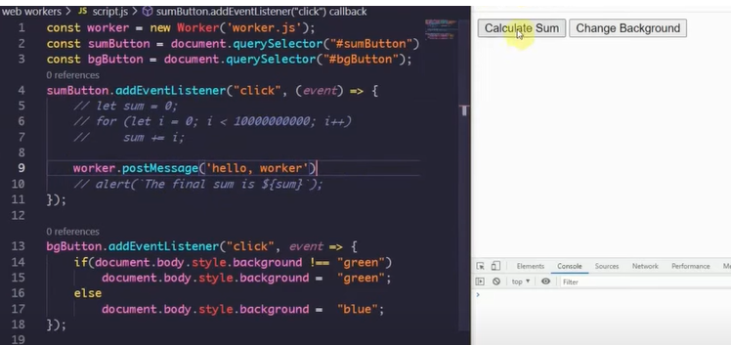

Now, the worker is doing all the heavy lifting and when a user tries to toggle b/w the background, he'll be able to do that.

1. To pass a message from the worker to the main thread - create an instance of the worker method being called in the main thread.
2. 